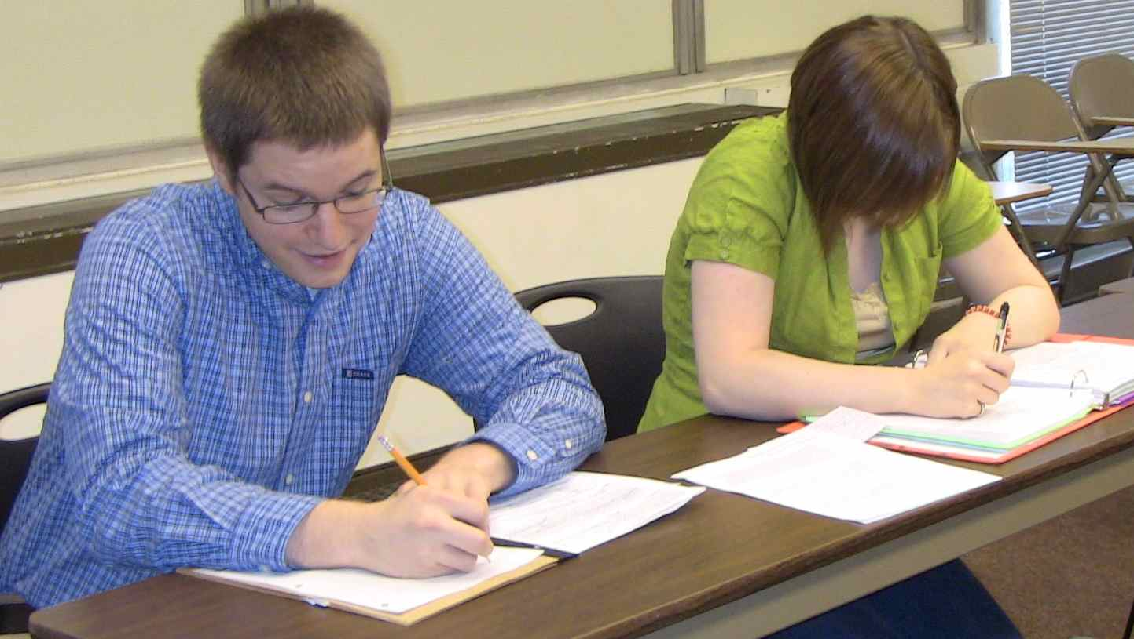

# Come have fun playing trivia and eating dinner with the Honors Club

# Meet at the restaurant at 7 pm

# Carpooling options are available

# RSVP to [jfeagin@highlands.edu](mailto:jfeagin@highlands.edu) by March 10

Jefferson’s Restaurant

* Trivia Night

## Trivia Night in Cartersville

4/21/14

6:30 – 9:30 PM

### Monday

!